### Fields And Relationship

**Fields** - Fields store data values that are required for a particular object in a record.

An object relationship in Salesforce is **a two-way association between two objects**. Relationships are created by creating custom relationship fields on an object. This is done so that when users view records, they can also see and access related data.

### Creation Of Text Field For The “Lecturer Details” Object

* 1. Click the gear icon and select Setup. This launches Setup in a new tab.
  2. Click the Object Manager tab next to Home.
  3. Select **Lecturer Details**
  4. Select Fields & Relationships from the left navigation
  5. Click New
  6. Select the **Text** as the Data Type, click next.
  7. For Field Label, enter **Lecturer Role**
  8. Enter Length 40
  9. Click Next, Next, then Save & New.

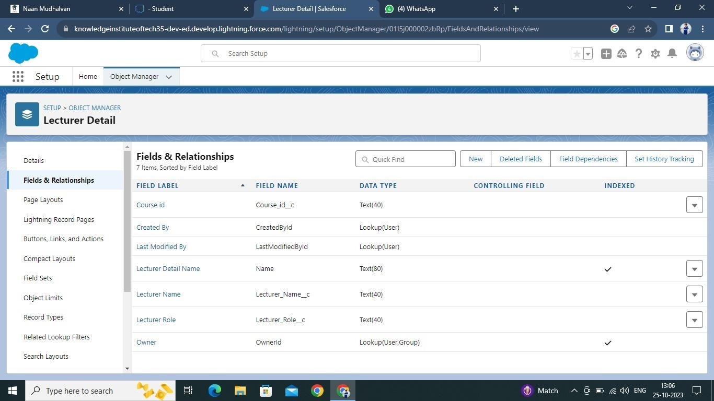

Lookup field on candidate object

1. Click the gear icon and select Setup. This launches Setup in a new tab.
2. Click the Object Manager tab next to Home.
3. Select candidate.
4. Select Fields & Relationships from the left navigation
5. Click New
6. Select the lookup as the Data Type, then click Next.
7. In related select **Semester**
8. For Field Label **Semester Name**, enter**.**
9. Click Next, Next, then Save & New

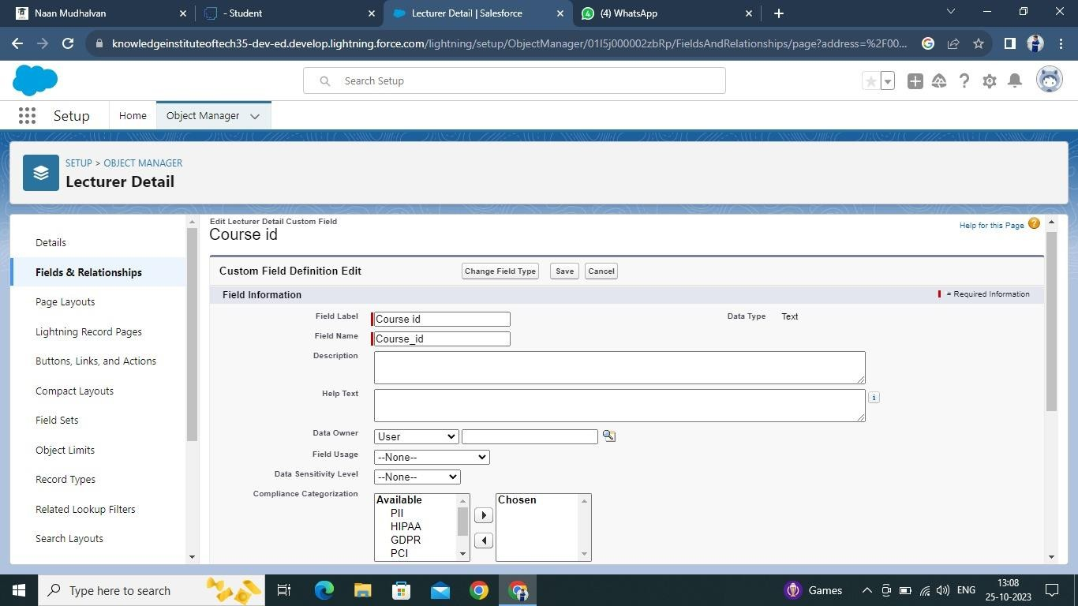

Note- Similarly create all lookup fields on their respective objects.

Let’s create an auto number field on **Candidate** object

1. Click the gear icon and select Setup. This launches Setup in a new tab.
2. Click the Object Manager tab next to Home.
3. Select **Candidate**.
4. Select Fields & Relationships from the left navigation
5. Click New
6. Select the Auto Number as the Data Type, then click Next.
7. For Field Label enter Candidate Roll Number**.**
8. Give a display format

10.Click Next, Next, then Save & New.

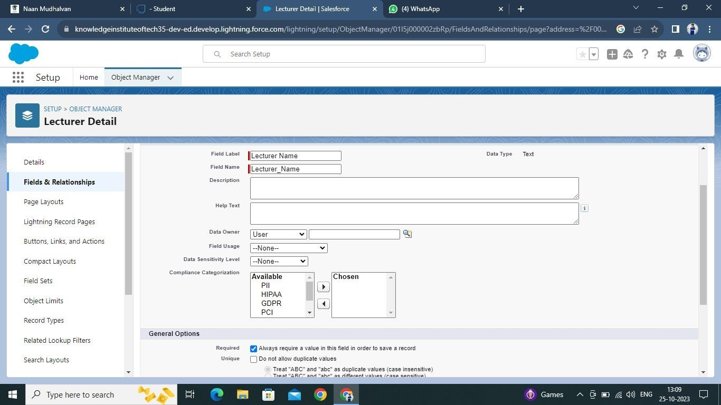

Let’s create a Formula field on **Internal results** object

1. Click the gear icon and select Setup. This launches Setup in a new tab.
2. Click the Object Manager tab next to Home.
3. Select **Internal results**.
4. Select Fields & Relationships from the left navigation.
5. Click New
6. Select the Formula as the Data Type, then click Next.
7. Give field label Candidate Roll Number
8. Select formula return type text, Click Next
9. Click Insert Field
10. Create and insert formula **Candidate r. Candidate Roll _ Number** , and then click Insert.
11. Click Next, Next, then Save.

